County Councillor Update  Coker Division SCC  Cllr Mark Keating  July 2021 |  | 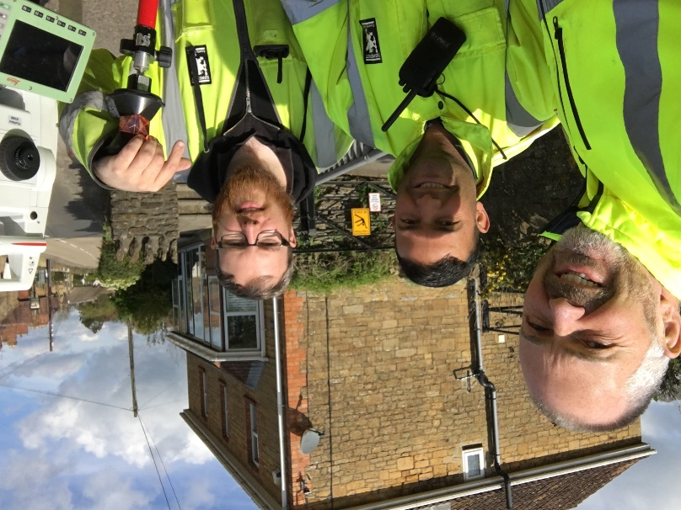
Representing you in - Barwick, Chiselborough, Closworth, East Chinnock, East Coker, Hardington Manderville, Hardington Marsh, Hardington Moor, Haselbury Plucknett, Middle Chinnock, Montacute, North Coker, North Perrott, Norton Sub Hamdon, ​Odcombe, Pendomer, Sutton Bingham, Stoford, West Chinnock, West Coker.
Useful Contacts Resources and Websites: Somerset Coronavirus Support Helpline: 0300 7906275
Cllr Mark Keating – Somerset County Council | E: MAKeating@Somerset.gov.uk | M: 07767 203968
South Somerset Area Highways Office | E: countyroads-southsom@somerset.gov.uk | T: 0300 123 2224
Report Pothole/Road Defect | E: roadsandtransportSD@somerset.gov.uk | T: 0300 123 2224
Report Dead Animal/Mud on Road | E: roadsandtransportSD@somerset.gov.uk | T: 0300 123 2224
Neil McWilliams – Highways Service Manager | E: countyroads-southsom@somerset.gov.uk | T: 0300 123 2224
Lee Norman/Derek Davies – Assist Highways Service Manager | E: countyroads-southsom@somerset.gov.uk | T: 0300 123 2224
Garry Warren/Rebecca Vaughan – Traffic Engineer. Traffic & Transport Development | E: countyroads-southsom@somerset.gov.uk | T: 0300 123 2224
Gully Emptying / Road Sweeper | E: chris.holley@southsomerset.gov.uk | T: 01935 462462
Nick Allen – SSDC Ranger Scheme | E: nick.allen@southsomerset.gov.uk | T: 01935 462462
Road Records & Highway Licensing | E: Roadrecords@Somerset.gov.uk | T: 0300 123 2224

Report Adult at Risk | adults@somerset.gov.uk |  |  | T: 0300 123 2224  T: Emergency: 999
Report Child at Risk | childrens@somerset.gov.uk |  |  | T: 0300 123 2224  T: Emergency: 999
Children’s Social Care Worker out of hours Emergency Duty Team |  |  |  | T: 0300 123 2327
Fostering and Adoption www.fosteradoptsomerset.org.uk | AandFRecruitmentEnquiryLine@somerset.gov.uk |  |  | T: 0800 587 9900
www.somersetwaste.gov.uk |  | ssdc@southsomerset.gov.uk | T: 01935 462462
https://www.travelsomerset.co.uk/ |  | Travel - Drive Bus Train Walk Cycle Weather
www.somerset.gov.uk |  | generalenquiries@somerset.gov.uk | T: 0300 123 2224
http://roadworks.org/ |  | Useful website for road works info
www.facebook.com/somersetcountycouncil |  | Somerset County Council Facebook page
https://roam.somerset.gov.uk/roam/map |  | Interactive Rights of Way Map / maintenance reporting
Coronavirus infection rates: As at 25th June the number of confirmed Covid cases in Somerset was 20,982 (up from 20,455 on 28th May) and the number of Covid-attributed deaths 799. The rate per 100,000 stands at 47.1 (5.5) for Somerset with Mendip at 40.7 (5.2), Sedgemoor at 74.7 (8.9), South Somerset 20.8 (3.6) and SW&T at 58.7 (5.2). The number of total deaths across the County is currently 19% below the 5-year average and the latest R-value for Somerset is between 1.0 and 1.5.

Despite significant progress and even for those, who have had both jabs, it is vitally important to remember, to observe Hands-Face-Space and to Ventilate indoor areas at all times

Road map out of lockdown: The final stage out of lockdown delayed until July 19th (with a July 5th review) is subject to Government assessment on four key criteria:
- the vaccine deployment programme continues successfully
- evidence shows vaccines are sufficiently effective in reducing hospitalisations and deaths in those vaccinated
- infection rates do not risk a surge in hospitalisations which would put unsustainable pressure on the NHS
- the assessment of the risks is not fundamentally changed by new variants
By this date the Government hopes to be in a position to remove all legal limits on social contact and to reopen remaining premises, including nightclubs. The final easing of restrictions on large events, performances and life events such as weddings will also be subject to the analysis of the outcomes from certain pilot events.
Somerset Coronavirus Support Helpline: A single phone number continues to be available for anyone in Somerset who needs Coronavirus-related support. 0300 790 6275, is open seven days a week from 8am to 6pm.

Vaccination programme roll-out: Somerset continues to have one of the highest vaccination rates in the country with the latest figures showing over 700,00 doses (both 1st and 2nd) Take up rates of both doses is very high: 80+ (96%), 75-79 (100%), 70-74 (98.3%), 65-69 (90.4%), 60-64 (95.2%), 55-59 (91.7%) and 50-54 (84.5). First dose rates are currently 45-49 (84.9%), 40-44 (90.4%), 35-39 (81.6%), 30-34 (71.5%) and 25-29 (44.2%).

One Somerset: An announcement on the future of local government in Somerset is expected from the Government before the Parliamentary summer recess on 22nd July. For more information visit: www.onesomerset.org.uk
Chinnock Hollow
Chinnock Hollow will remain closed until a full survey has been completed to ascertain safety/risks and any associated costs regarding works that might be necessary between. I will update all Parish Councils when we know more.
A30
The A30 from Uplands Terrace at West Coker to White Post Garage is due to be surfaced dressed in the next weeks. A degree of road skimming is involved with prep works.

A37 Barwick/Whistle Bridge
Resurfacing works and new signage are due to commence in the next weeks
Consultation on A38 Burnham to Bristol airport upgrade: Proposals to make improvements to one of Somerset’s key roads are being shared with the public. Somerset County Council and North Somerset Council are working in partnership on a number of proposed schemes on the A38 Burnham-on-Sea to just outside Bristol. The scheme seeks to improve journey reliability times, road safety and better connect local communities – whether by car, public transport or active travel. The public are invited to comment on these plans using the interactive map on the engagement website, https//:a38mrn-engagement.com The feedback will help inform the A38 Major Business Case that will be submitted to Government for approval later in the year.
Tackling Somerset’s Childminder shortage: The number of registered childminders in the county has decreased by over 31% since September 2015. In response, Somerset County Council has been working hard to boost numbers and is tackling the shortage of childminders across the county. In addition to a ‘Golden Hello’ grant worth £250.00, guidance and training is being offered to newly registered childminders which supports them through Ofsted registration and beyond. Anyone interested in attending an information session on Wednesday 21 July (6.30-7pm) is urged to register through: http://www.eventbrite.co.uk/e/childminding-in-somerset-virtual-information-session-tickets-157986252133
Pioneering Climate adaptation website: A new web-based app gives the opportunity to explore the impacts of climate change on the Somerset Levels. The app, created as part of the Adapting the Levels project to help local people turn individual ideas into plans for collective action, focusing particularly on the challenges of flooding and drought. Adapting the Levels has worked with SCC, Somerset Wildlife Trust, Farming and Wildlife Advisory Group, Parish and Town councils, businesses and communities to create draft pathways, which are available to explore online. Everyone is invited to view the pathways, comment and add ideas, by visiting www.adaptingthelevels.co.uk
Investing in Children and Young people: An ambitious and innovative approach to improve the life chances of Somerset’s highest needs children has given the green light. The ten-year programme will deliver a new way of working which will address the needs of Somerset’s most complex children and young people who are cared for by the Council. The council will be seeking a strategic partner(s) to provide up to 10 new small homes in Somerset, linking these to foster carers and therapeutic education to provide a seamless service that will help children and young people to grow and flourish. Combining foster care and small homes will offer young people the experience of a stable home environment and the opportunity to live with a family when they are ready. Skilled therapists from different agencies and teachers will work together to provide wraparound support designed to meet their individual needs.
Special Educational Needs Survey: Parents, carers, children, young people and practitioners are being asked to complete a short confidential survey to help shape services for children and young people with special educational needs and/or disabilities (SEND). Together with NHS Somerset Clinical Commissioning Group and the Somerset Parent Carer Forum, SCC are keen to hear views of children and young people who have SEND, their parents, carers and families, and the practitioners who support them. The short survey will close on Friday 9 July. www.somerset.gov.uk/360survey

